**Curriculum Vitae**

## Personal Information

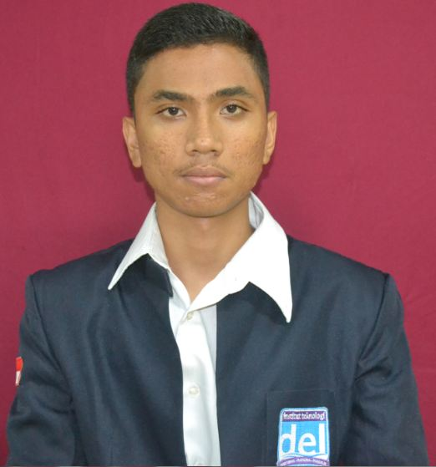

**Name** : Leo Parhaposan Pakpahan

**Email** : leopakpahan43@gmail.com

**Place/Date of Birth** :Medan, January 14th, 1998

**Contact Address** :Sibolga, Jln.Oswald Siahaan No 12.A Pandan

**Contact Number** : +6282276449886

**Marital Status** : Single

**Gender** : Male

**Hobbies** : Playing Guitar, Badminton.

## Formal Education

|  |  |  |  |
| --- | --- | --- | --- |
| **Level** | **School/Address** | **Period** | **GPA** |
| Diploma of Informatics Engineering Student | Del Institute of Technology | 2015– Present | 2.4 (until 3 Semester) |
| Senior High School | SMA Sutomo 1 Medan | 2012 – 2015 | - |
| Junior High School | SMP Sutomo 1 Medan | 2009 – 2012 | - |
| Elementary School | SD Methodist, Tanjung Morawa | 2004 – 2009 | - |

## Foreign Language

|  |  |
| --- | --- |
| **Language** | **Level** |
| English | Intermediate |

**Achievements/Awards**

1. Participant of Del Mobile Developer Workshop 2016
2. Participant of Compest Microsoft Students Partner 2015

|  |
| --- |
|  |

**Societal Task**

1. Member of IT Del Del Mobile Developer Club
2. Member of IT Del Martial Arts Community
3. Chairman of Sibolga Bersatu in IT Del
4. Member of Sunday school teacher at Balige
5. Member of Crew of Discipline of Del Christmas 2015

**Technical Skills**

| **Technical Specification** | **Skills Specification** | **Experience** | **Level** |
| --- | --- | --- | --- |
| **Programming Language** | C | Having one year experience learning basic and intermediate concept of C Programming, developing application, data structure by using C, one semester experience using C programming language in programming competition, and one semester experience using C programming language in learning system programming. | Intermediate |
| Java(J2SE) | Having one year experience learning basic and intermediate concept of Java Procedural and Object Oriented Programming, one semester experience using Java programming language in programming competition, developing desktop applications  by using Java Standard Edition and one semester learning and developing distributed system applications by using Java Standard Edition. | Intermediate |
| PHP | Having one semester experience learning basic and intermediate concept of PHP Procedural and Object Oriented Programming, developing web-based applications  by using Laravel-Framework. | Good |
| Python | Having one semester experience learning basic and intermediate concept of PHP Procedural and Object Oriented Programming, developing web-based applications  by using Django Framework | Good |
| **IDE** | Netbeans 8.2.0 | Having three semester experience using Netbeans in building web, desktop and mobile application. | Intermediate |
| Micorosoft Visual Studio 2008 for operating system windows and linux | Having one semester experience of operating system using C | Good |
| Eclipse | Having one semester experience for building website and still learning this tool | Intermediate |
| Spring Tools Suite | Having one semester experience for building website using spring and still learning this tool | Intermediate |
| Android Studio | Having one month experience for building android application and still learning this tool | Beginner |
| **Web development** | HTML | Having one month learning web design concept and implementing it by creating small websites. | Intermediate |
| Java Server Page | Having one semester experience in making more interactive Java Server Pages by embedding JavaScript, CSS, HTML in Java(J2SE). | Intermediate |
| PHP | Having one semester experience in developing web application using Java Standard Edition and PHP-Web Scripting language and MySQL Database | Good |
| Ajax | Having one semester experience in developing web application using php and java | Beginner |
| **­­­­­­­­­­­Database System** | Microsoft Access | Having one year experience in learning MySQL, executing queries and using wizard with Microsoft Access | Intermediate |
| MySQL | Having one semesters experience in learning MySQL, executing queries and other commands, making other program that could access the database | Intermediate |
| SQL Server | Having one semester experience in learning SQL Server as database | Intermediate |
| **Operating System** | Windows 7 Professional | Having 3 years experience in using this Windows environment | Intermediate |
| Windows 8.1 | Having two semester experience in using Windows 8.1 environment | Intermediate |
| Linux | Having one year experience in using linux environment | Intermediate |
| **Office** | Microsoft Word | Having experience using Microsoft Word, Microsoft Excel and Microsoft PowerPoint since the first semester in Junior High School and still use them for documentation and presentation. And use to do mathematical operation | Intermediate |
| Microsoft PowerPoint | Intermediate |
| Microsoft Excel | Intermediate |
| **Miscellaneous** | Adobe Photoshop | Experienced in creating and editing images using features on Adobe Photoshop | Intermediate |
| Macromedia Flash MX | Having one Semester experience in learning animation design by using Macromedia Flash MX. | Beginner |
| Yii Framework | Having one month experience in creating web application and information system with PHP | Good |
| Spring Framework | Having one semester experience in developing web application using Java Enterprise Edition | Intermediate |
| Laravel Framework | Having one semester experience in developing web application using php | Intermediate |
| Play Framework | Having one semester experience in developing web application using java | Good |
| Django Framework | Having one semester experience in developing web application using python | Good |
| Networking tool | Packet Tracer | Having one semester Experience in learning to design a network, basic configure on the network and how to use network tool by using Packet Tracer | Good |

­­­­­­­­­­­­

## Projects Undertaken During Study:

|  |  |  |
| --- | --- | --- |
| Project Name | : | E-Commerce Go Market |
| Project Owner | : | Lesson of Web Application (PHP Language) |
| Duration | : | October 2016 – December 2016 (2 Month) |
| Platform & Skills | : | This project is developed under Windows 10 using PHP, HTML, CSS, JavaScript, NetBeans 8.0, Sqlyog and XAMPP. |
| Description | : | The aim of this project is about to make easy for people around Toba Samosir be able to buy some ingredients in the kitchen such as chili, tomatoes, garlic, onion, etc. |
| Role | : | Project Manager and Programmer. |
| Responsibilities | : | Analyst requirement, developing and testing application. |

|  |  |  |
| --- | --- | --- |
| Project Name | : | Sistem Informasi PAM (Perusahaan Air Minum) |
| Project Owner | : | Lesson of Pemograman Berbasis Object |
| Duration | : | May 2016 – July 2016 (1 Month) |
| Platform & Skills | : | This project is developed under Windows 8.1 using JavaFx, Java language, NetBeans 8.0, Sqlyog and XAMPP. |
| Description | : | The aim of this project is about to make easy for who want to purchase a bill of water on each people that use this company |
| Role | : | Programmer. |
| Responsibilities | : | Analyst requirement, developing and testing application. |
|  |  |  |

|  |  |  |
| --- | --- | --- |
| Project Name | : | Sistem Informasi Badan Eksekutif Mahasiswa (BEM) |
| Project Owner | : | Lesson of Pemrograman Berbasis Web |
| Duration | : | December 2016 – January 2017 (1 Month) |
| Platform & Skills | : | This project is developed under Windows 10 using HTML, CSS, JavaScript, Ajax, Java language, Spring Suite Tools, Sqlyog and XAMPP. |
| Description | : | The aim of this project is about to make easy for who get information of current activiy and next Activity. |
| Role | : | Programmer. |
| Responsibilities | : | Analyst requirement, developing and testing application. |
|  |  |  |

## Statement of Purpose:

All the above activities have helped me in many ways so I

* I am comfortable working in teams
* Accept challenge and responsibility
* Have good communication skills
* Remain focused and dedicated towards my work
* Have ability to learn a new thing quickly
* I am comfortable finishing my work

I hereby certify that the information provided is true.

Medan, February 20th, 2017

Daniel Giovanni Sinaga